График проведения ВПР- 2024 г.[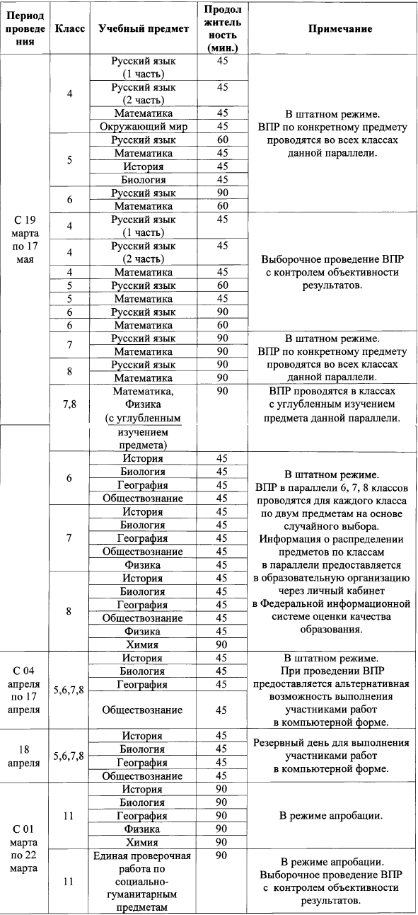](https://www.ivege.ru/uploads/files/2023/%D0%94%D0%B5%D1%8F%D1%82%D0%B5%D0%BB%D1%8C%D0%BD%D0%BE%D1%81%D1%82%D1%8C/%D0%92%D0%9F%D0%A0/%D0%B2%D0%BF%D1%80/1.png)